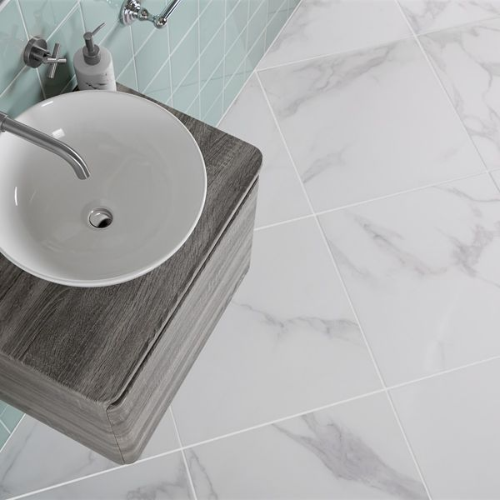

Ruscello White Gloss 60x60 Tiles: <https://www.wallsandfloors.co.uk/ruscello-gloss-carrara-marble-effect-tiles>



Rustic Blue Reclaimed Wood Effect Tiles:

<https://www.wallsandfloors.co.uk/reclaimed-wood-effect-tiles-rustic-blue-wood-plank-tiles>

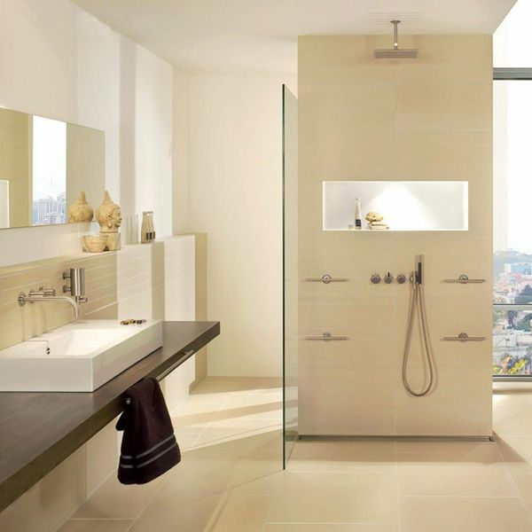

Lounge Polished Ivory Tiles: <https://www.wallsandfloors.co.uk/lounge-tiles-polished-ivory-floor-tiles>

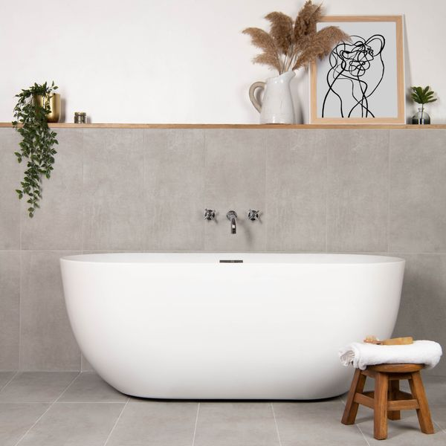

Scultura Grigio Stone Effect Tiles: <https://www.wallsandfloors.co.uk/scultura-grigio-stone-effect-tiles>

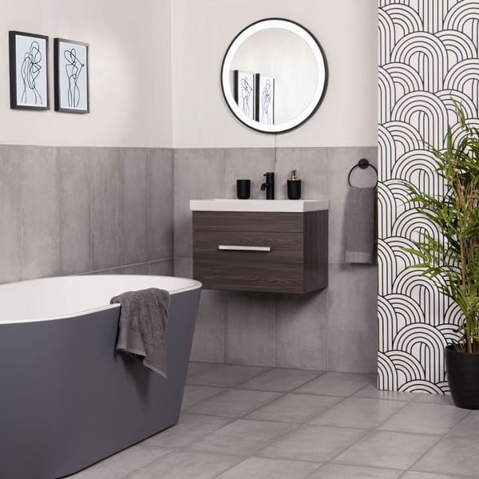

Samphire Matt Grey Tiles: <https://www.wallsandfloors.co.uk/samphire-matt-white-tiles>

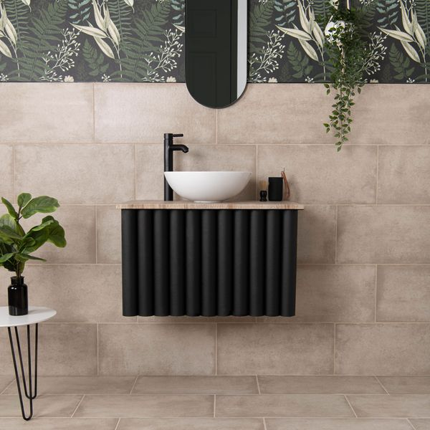

Samphire Matt Beige Tiles: <https://www.wallsandfloors.co.uk/samphire-matt-beige-tiles>